Plots below, **after** changing mortality

|  |  |  |  |
| --- | --- | --- | --- |
| **Recruitment score of 0.0022** | | | |
| Age imp val =1  MR = OFF  Recruitment rate of 0.0022 |  |  |  |
| Age imp val =1  MR = 1  Pop_init  MR_mean = 0.653 MR_sd = 0.366  Recruitment rate of 0.0022 |  |  | Recruitment cant keep up as age impact + Mr impact are compounded (see age & MR = 0.5 at late intro) |
| Age imp val = 2  MR = 1  Pop_init  MR_mean = 0.653 MR_sd = 0.366  Recruitment rate of 0. 0022 | Error: All dead at time 174 |  |  |
| Age imp val = 1  MR = 0.5  Pop_init  MR_mean = 0.653 MR_sd = 0.366  Recruitment rate of 0. 0022 |  |  |  |
|  |  |  |  |
| Age imp val = 1.5  MR = 0.5  Pop_init  MR_mean = 0.653 MR_sd = 0.366  Recruitment rate of 0.005 | Error: All dead at time 283 |  |  |
| Age imp val = 1  MR = 0.1  Pop_init  MR_mean = 0.653 MR_sd = 0.366  Recruitment rate of 0. 0022 |  |  |  |
| Age imp val = 1  MR = 0.01  Pop_init  MR_mean = 0.653 MR_sd = 0.366  Recruitment rate of 0. 0022 |  |  |  |
| Changing MR age impact | | | |
| Age imp val =1  MR = 1  Turned off MR age impact  Pop_init  MR_mean = 0.653 MR_sd = 0.366  Recruitment rate of 0.005 | All dead at time 64 |  | Increased mortality as MR age impact reduces MR score overall |
| Late MR intro | | | |
| Age imp val =1  MR = 1 – late intro at TP=1000  Pop_init  MR_mean = 0.653 MR_sd = 0.366  Recruitment rate of 0. 0022 |  |  |  |
| Age imp val = 0.5  MR = 0.5 – late intro at TP=1000  Pop_init  MR_mean = 0.653 MR_sd = 0.366  Recruitment rate of 0. 0022 |  |  |  |

|  |  |  |  |
| --- | --- | --- | --- |
| **Recruitment score of 0.005** | | | |
| Age imp val =1  MR = OFF  Recruitment rate of 0.001 |  |  |  |
| Age imp val =1  MR = 1  Pop_init  MR_mean = 0.653 MR_sd = 0.366  Recruitment rate of 0.005 |  |  | Final individual mortality rates (calculated by complementary probability of both) are punished by MR hitting 0, therefore lower than age |
| Age imp val = 2  MR = 1  Pop_init  MR_mean = 0.653 MR_sd = 0.366  Recruitment rate of 0.005 | Error: All dead at time 198 |  |  |
| Age imp val = 1  MR = 0.5  Pop_init  MR_mean = 0.653 MR_sd = 0.366  Recruitment rate of 0.005 |  |  |  |
| Age imp val = 1.5  MR = 0.5  Pop_init  MR_mean = 0.653 MR_sd = 0.366  Recruitment rate of 0.005 | Error: All dead at time 313 |  |  |
| Age imp val = 1  MR = 0.1  Pop_init  MR_mean = 0.653 MR_sd = 0.366  Recruitment rate of 0.005 |  |  |  |
| Age imp val = 1  MR = 0.01  Pop_init  MR_mean = 0.653 MR_sd = 0.366  Recruitment rate of 0.005 |  |  |  |
| Changing MR age impact | | | |
| Age imp val =1  MR = 1  Turned off MR age impact  Pop_init  MR_mean = 0.653 MR_sd = 0.366  Recruitment rate of 0.005 |  |  | Increased mortality as MR age impact reduces MR score overall |
| Late MR intro | | | |
| Age imp val =1  MR = 1 – late intro at TP=1000  Pop_init  MR_mean = 0.653 MR_sd = 0.366  Recruitment rate of 0.005 |  |  |  |
| Age imp val =1  MR = 0.5 – late intro at TP=1000  Pop_init  MR_mean = 0.653 MR_sd = 0.366  Recruitment rate of 0.005 |  |  |  |
| Age imp val =1  MR = 0.1 – late intro at TP=1000  Pop_init  MR_mean = 0.653 MR_sd = 0.366  Recruitment rate of 0.005 |  |  | Stabilises at a lower MR timepoint regardless because of higher inheritability of MR resistance |

|  |  |  |
| --- | --- | --- |
| Updated MR inheritance + competition + MR scale (removed initial rescale, converted all to 0-1) – Recruitment 0.003 | | |
| age_impact = 1.0  MR_death_impact = F  MR_lateintro = F  recruitment_const = 0.003  comp_impact = 0.9 |  |  |
| age_impact = 1.0  MR_death_impact = 0.05  MR_lateintro = F  recruitment_const = 0.003  comp_impact = 0.9 |  |  |
|  |  |  |
| age_impact = 1.0  MR_death_impact = 0.1  MR_lateintro = F  recruitment_const = 0.003  comp_impact = 0.9 |  |  |
| age_impact = 1.0  MR_death_impact = 0.1  MR_lateintro = T - 2000  recruitment_const = 0.003  comp_impact = 0.9 |  |  |
| age_impact = 1.0  MR_death_impact = 0.15  MR_lateintro = F  recruitment_const = 0.003  comp_impact = 0.9 |  |  |
| age_impact = 1.0  MR_death_impact = 0.2  MR_lateintro = F  recruitment_const = 0.003  comp_impact = 0.9 |  |  |
| age_impact = 1.0  MR_death_impact = 0.2  MR_lateintro = T - 2000  recruitment_const = 0.003  comp_impact = 0.9 |  |  |
| age_impact = 1.0  MR_death_impact = 0.5  MR_lateintro = F  recruitment_const = 0.003  comp_impact = 0.9 |  |  |
| age_impact = 1.0  MR_death_impact = 0.5  MR_lateintro = T - 2000  recruitment_const = 0.003  comp_impact = 0.9 |  |  |

|  |  |  |
| --- | --- | --- |
| Pop 1  Age imp val = 1.0  MR imp val = 0.5  Pop 2  Age imp val = 1.0  MR imp val = 0.05 | Blue = runs without maladaptation events (running it solo)  Red = runs with maladaptation events (running both pops in conjunction)  Where for each side pop 1, maladapts with pop 2 (triangle events)  For the left side, pop 1, the maladapted pop is brought higher with the influence of pop2  For the right side, the population is |  |

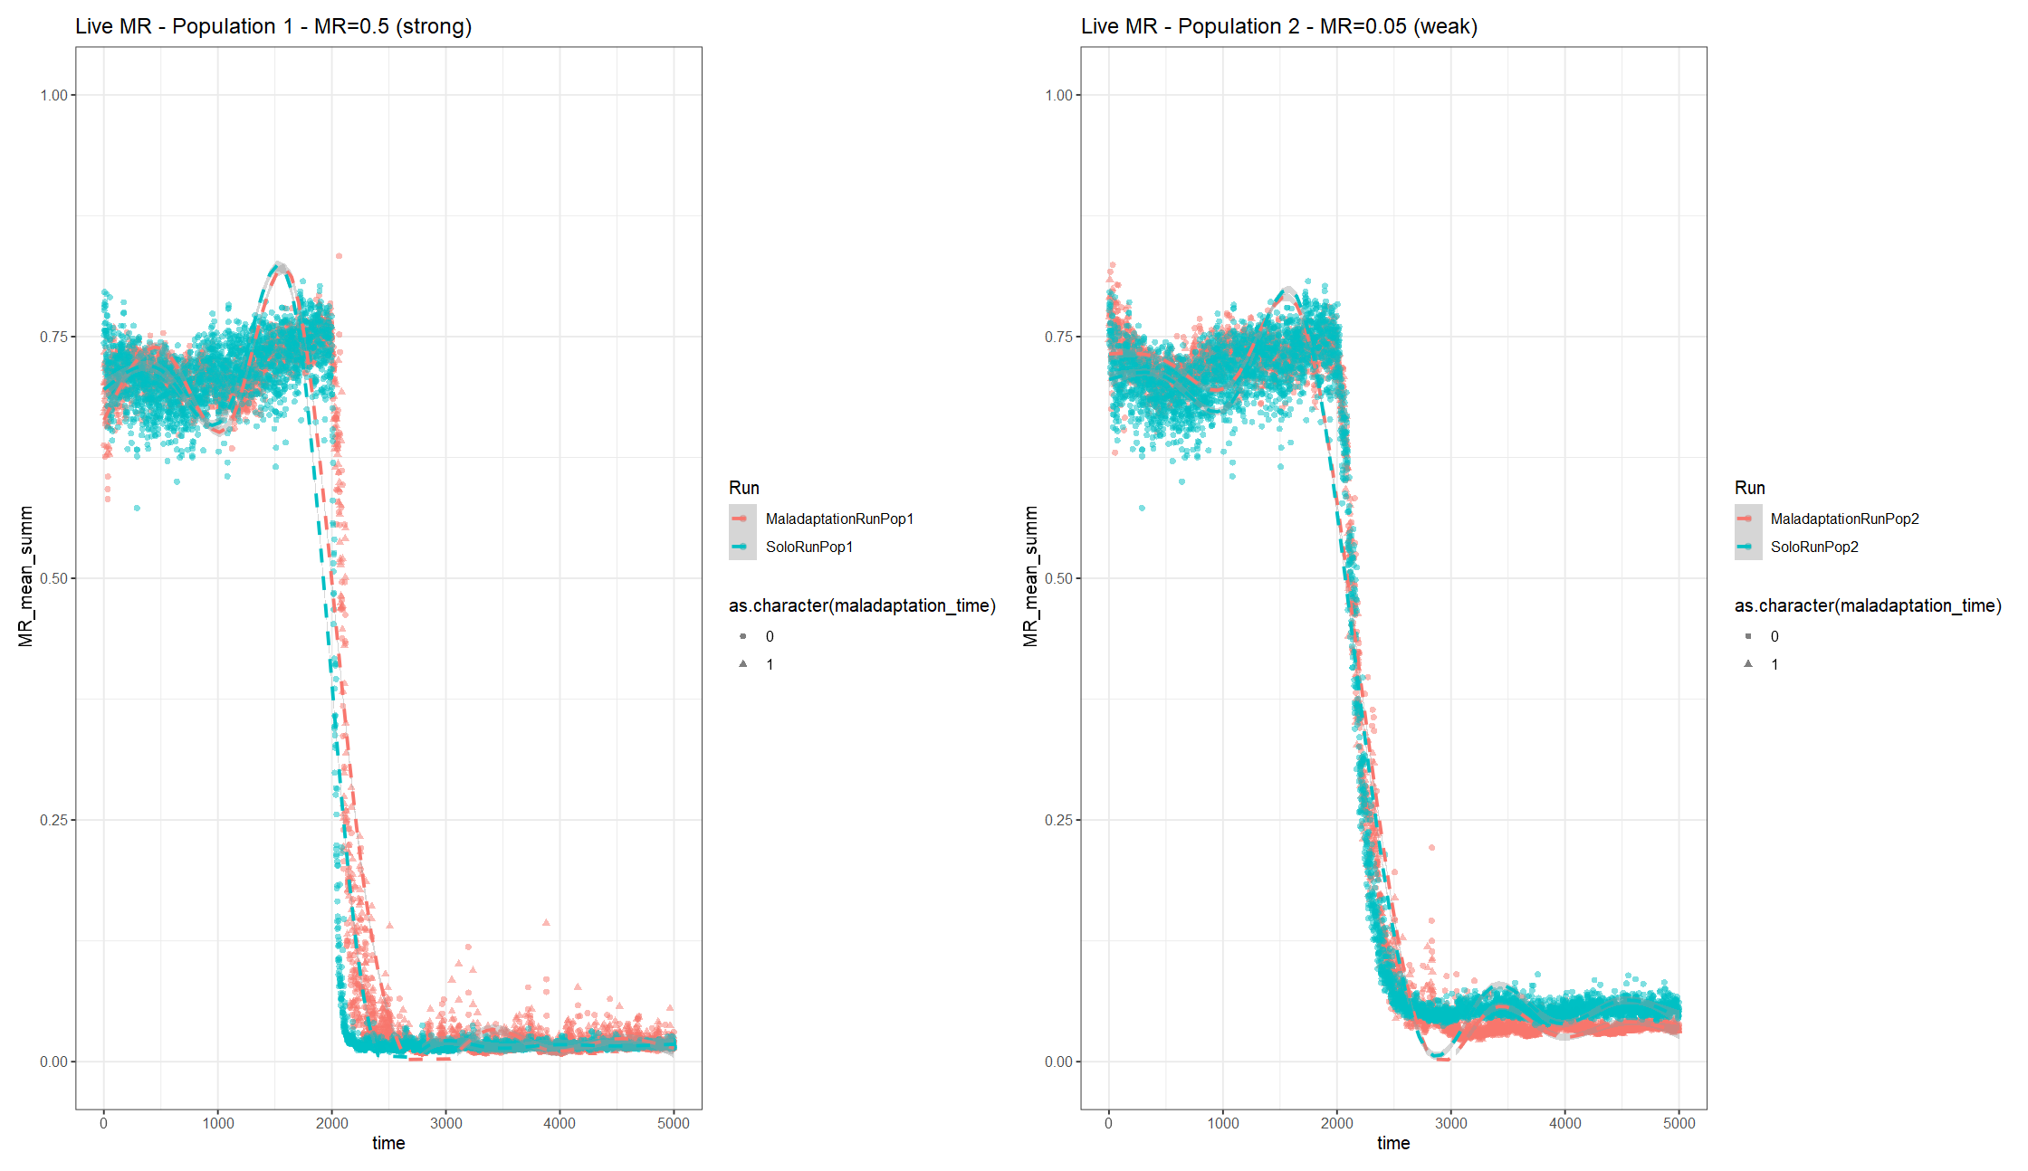

**Change MR recruitment to ^2 instead of ^4**

|  |  |  |
| --- | --- | --- |
| Pop 1  age_impact = 1.0  MR_death_impact = 0.5  MR_lateintro = T - 2000  recruitment_const = 0.003  comp_impact = 0.9 |  |  |
| Pop 2  age_impact = 1.0  MR_death_impact = 0.05  MR_lateintro = T - 2000  recruitment_const = 0.003  comp_impact = 0.9 |  |  |
| Pop 1  Age imp val = 1.0  MR imp val = 0.5  Pop 2  Age imp val = 1.0  MR imp val = 0.05 | Blue = runs without maladaptation events (running it solo)  Red = runs with maladaptation events (running both pops in conjunction)  Where for each side, red, pop 1, maladapts with pop 2 (triangle events):   * For the left side, pop 1, the maladapted pop is **pulled up** with the influence of pop2 (less resistant) * For the right side, pop 2 is **pulled** **down** with the influence of pop1 (more resistant) |  |

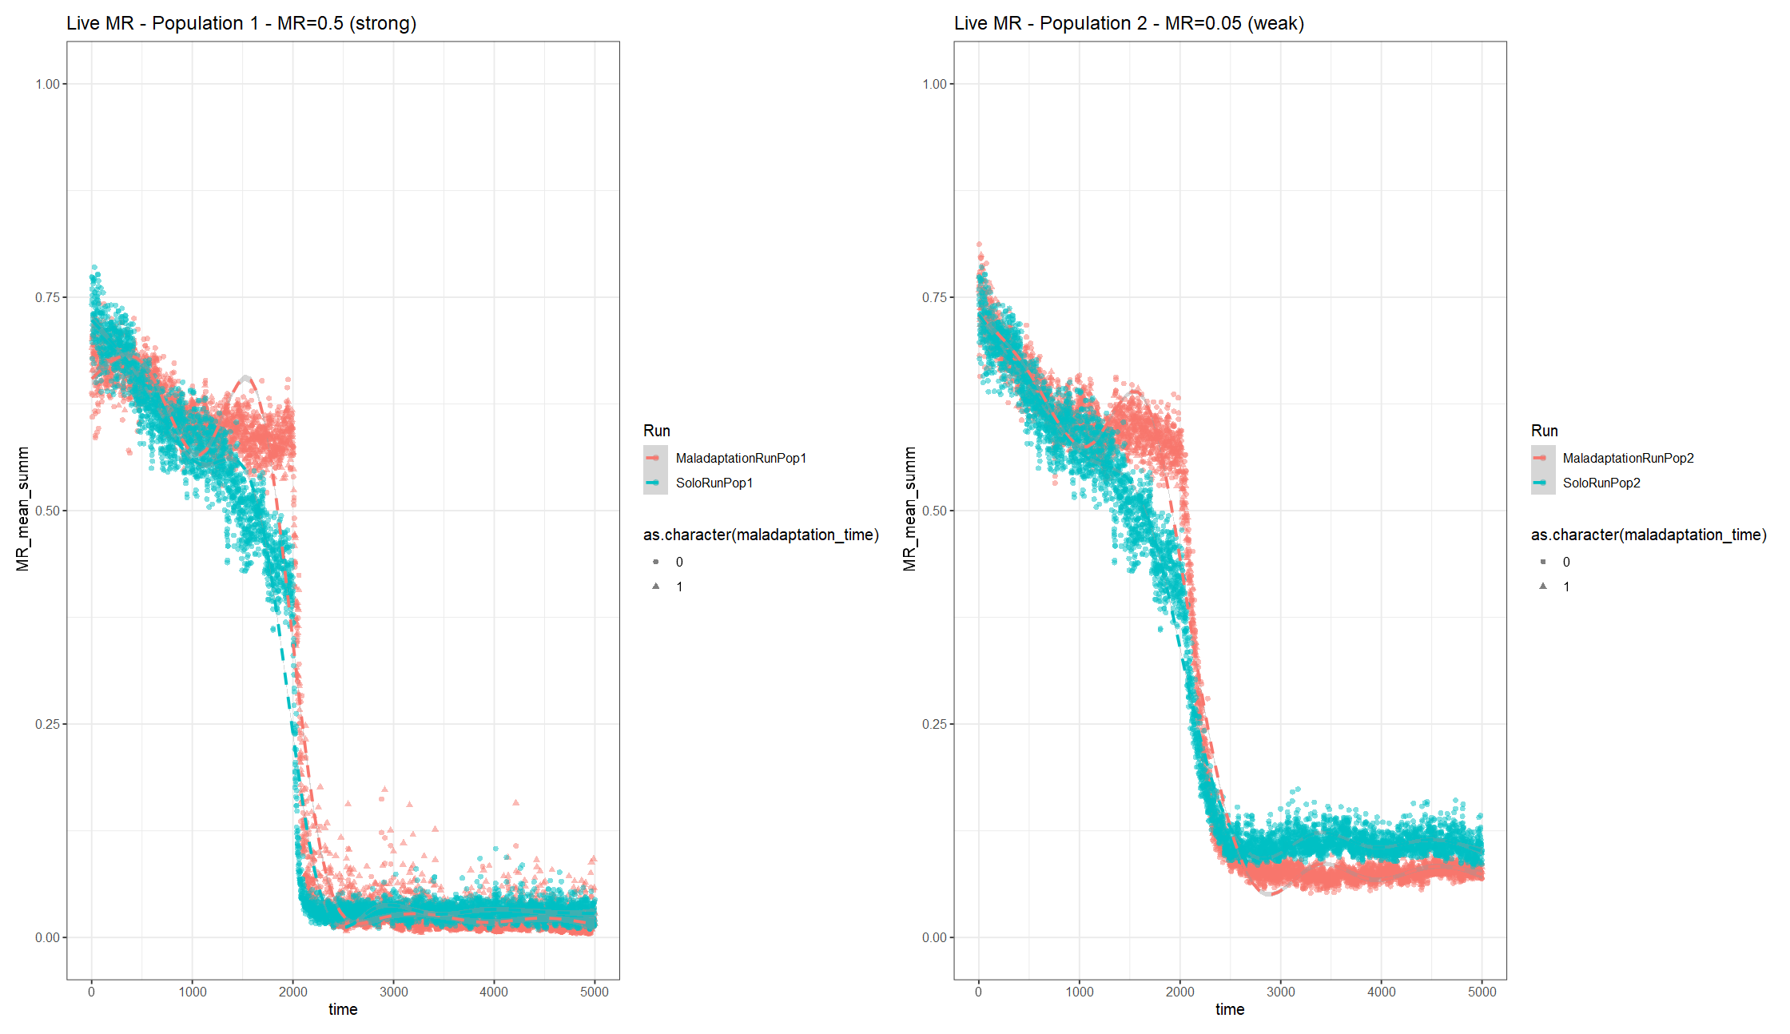

|  |  |  |  |  |  |
| --- | --- | --- | --- | --- | --- |
| Impact _ MR | 0.10 | 0.12 | 0.14 | 0.16 | 0.18 |
|  |  |  |  |  |  |
|  |  |  |  |  |  |
|  |  |  |  |  |  |

**Change MR recruitment to ^2 instead of ^4; adjust MR inheritance by -0.08**

|  |  |  |
| --- | --- | --- |
| age_impact = 1.0  MR_death_impact = F  MR_lateintro = F  recruitment_const = 0.003  comp_impact = 0.9 |  |  |
| age_impact = 1.0  MR_death_impact = 0.1  MR_lateintro = T - 1000  recruitment_const = 0.003  comp_impact = 0.9 |  |  |
| age_impact = 1.0  MR_death_impact = 0.2  MR_lateintro = T - 1000  recruitment_const = 0.003  comp_impact = 0.9 |  |  |
|  |  |
| T=2000 |  |  |
|  |  |
| age_impact = 1.0  MR_death_impact = 0.5  MR_lateintro = F  recruitment_const = 0.003  comp_impact = 0.9 |  |  |
| age_impact = 1.0  MR_death_impact = 0.5  MR_lateintro = T - 1000  recruitment_const = 0.003  comp_impact = 0.9 |  |  |
| age_impact = 1.0  MR_death_impact = 0.75  MR_lateintro = T - 1000  recruitment_const = 0.003  comp_impact = 0.9 |  |  |
| age_impact = 1.0  MR_death_impact = 0.8  MR_lateintro = T - 2000  recruitment_const = 0.003  comp_impact = 0.9 |  |  |
| age_impact = 1.0  MR_death_impact = 1.0  MR_lateintro = T - 1000  recruitment_const = 0.003  comp_impact = 0.9 |  |  |
|  |  |
| Pop 1  Age imp val = 1.0  MR imp val = 0.2  Pop 2  Age imp val = 1.0  MR imp val = 0.8 | Was run without maladaptation at the start to confirm initial pops overlapped  Q: Why does it drop at the start? |  |

# Intervention

Data_sim_3

Altered mortality – age of interception indivs *4 until mortality_age_shift/4 (~35)

## Base:

* Recruitment adjustment = 0 & ^2
* MR=0.12
* MR introduced at 1000

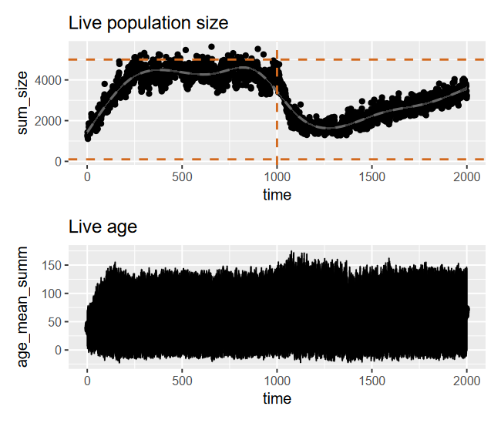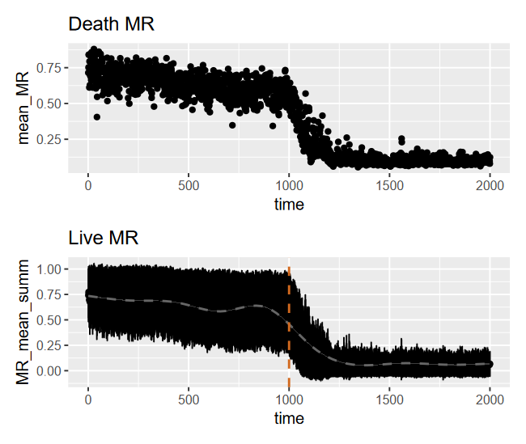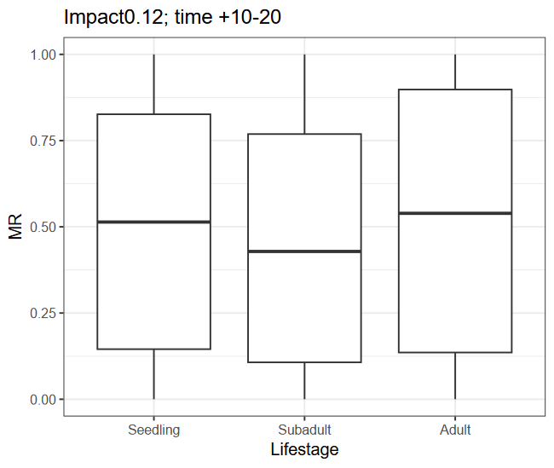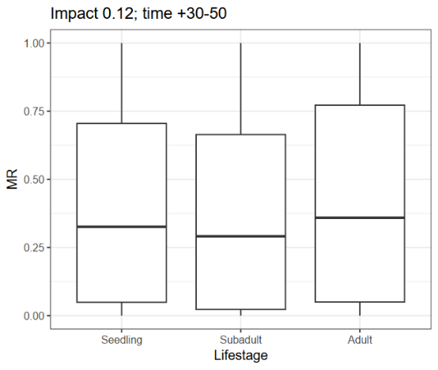

## Intervention_100-0.15-0.1_T1025:

* Recruitment adjustment = 0 & ^2
* MR=0.12
* MR introduced at 1000
* intercept_timepoint = 1025
  + Dropped mean MR from 0.499 -> 0.491
* intercept_indiv = 100
* intercept_MR_mean = 0.15
* intercept_MR_sd = 0.1

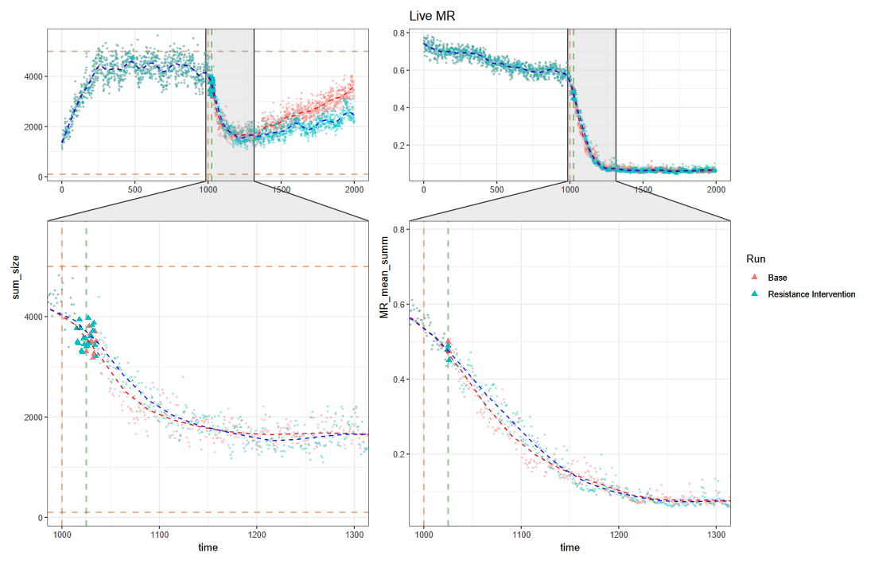

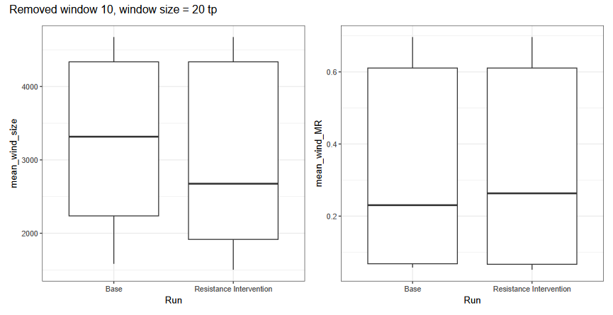

## Intervention_300-0.15-0.1_T1025:

* Recruitment adjustment = 0 & ^2
* MR=0.12
* MR introduced at 1000
* intercept_timepoint = 1025
  + Dropped mean MR from 0.499 -> 0.475
* intercept_indiv = 300
* intercept_MR_mean = 0.15
* intercept_MR_sd = 0.1

# A tibble: 2 × 2

Run min_pop_size

*<chr>* *<dbl>*

1 Base 1583.

2 Resistance Intervention 1271.

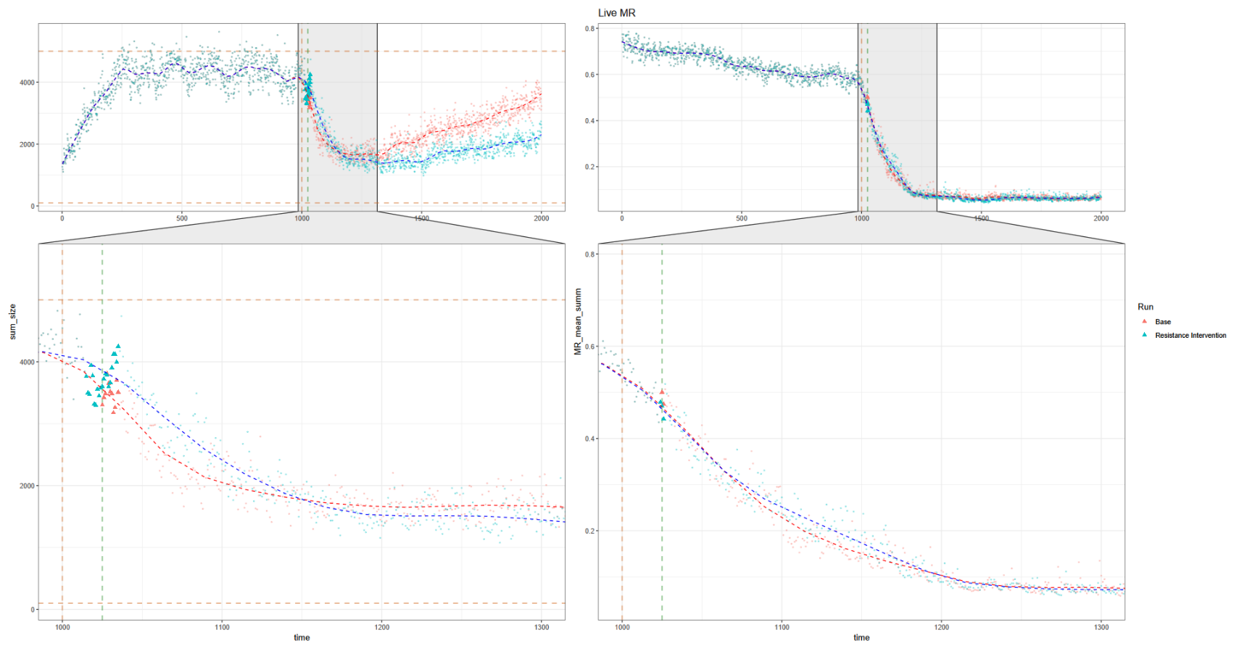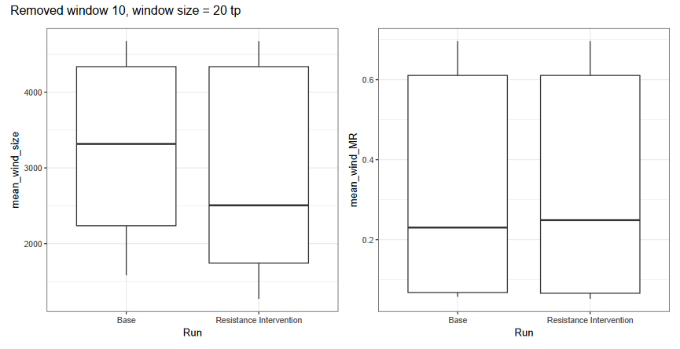

## Intervention_300-0.10-0.05_T1025:

* Recruitment adjustment = 0 & ^2
* MR=0.12
* MR introduced at 1000
* intercept_timepoint = 1025
  + Dropped mean MR from 0.499 -> 0.4718
* intercept_indiv = 300
* intercept_MR_mean = 0.10
* intercept_MR_sd = 0.05

> live_size_wind_mean %>%

+ group_by(Run) %>%

+ summarise(min_pop_size = min(mean_wind_size))

# A tibble: 2 × 2

Run min_pop_size

*<chr>* *<dbl>*

1 Base 1583.

2 Resistance Intervention 1719.

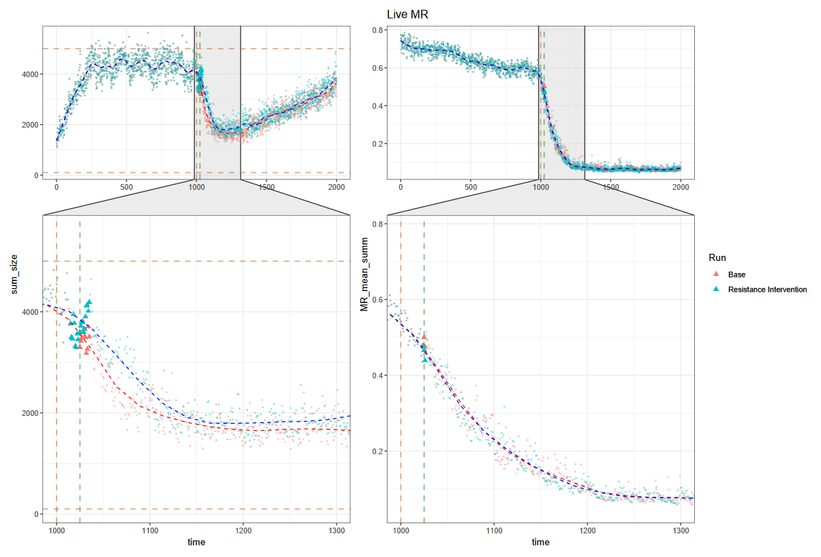

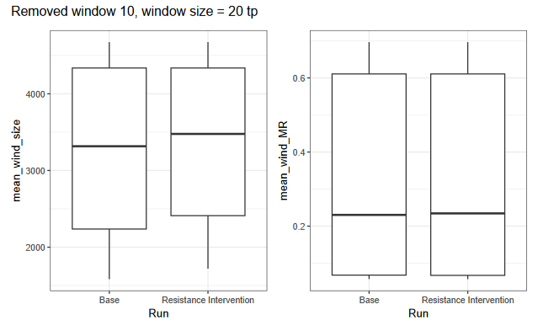

## Intervention_300-0.15-0.10_T1050:

* Recruitment adjustment = 0 & ^2
* MR=0.12
* MR introduced at 1000
* intercept_timepoint = 1050
  + Dropped mean MR from 0.4325276 -> 0.4073158
* intercept_indiv = 300
* intercept_MR_mean = 0.15
* intercept_MR_sd = 0.10

> live_size_wind_mean %>%

+ group_by(Run) %>%

+ summarise(min_pop_size = min(mean_wind_size))

# A tibble: 2 × 2

Run min_pop_size

*<chr>* *<dbl>*

1 Base 1583.

2 Resistance Intervention 1358.

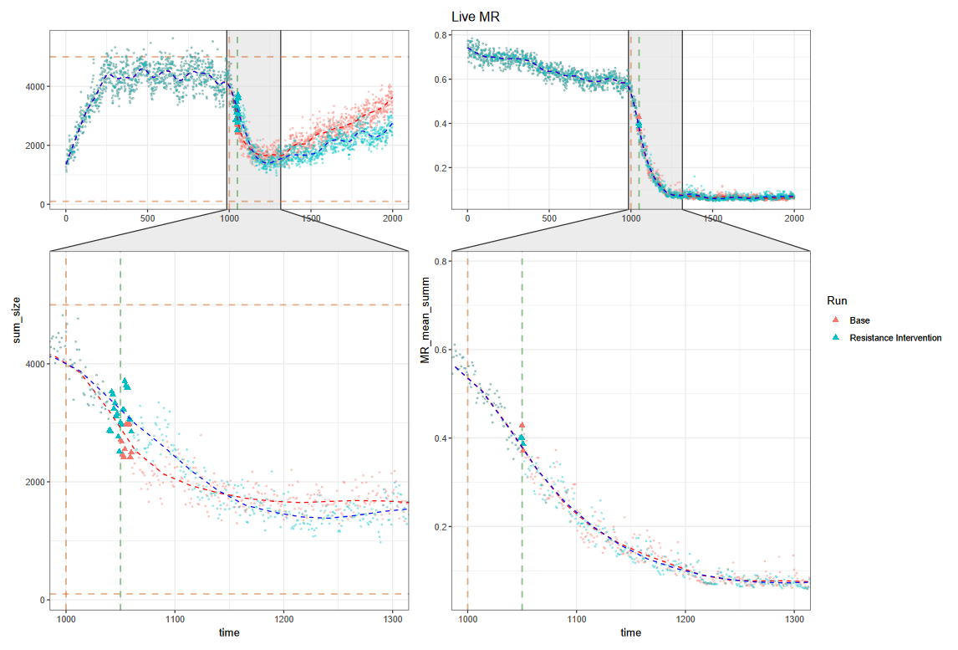

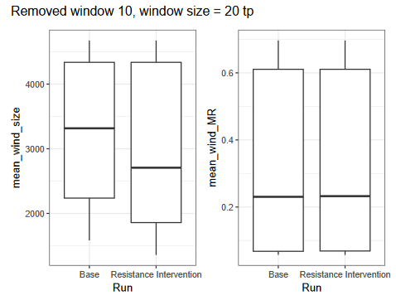

## Intervention_500-0.15-0.1_T1025:

* Recruitment adjustment = 0 & ^2
* MR=0.12
* MR introduced at 1000
* intercept_timepoint = 1025
  + Dropped mean MR from 0.499 -> 0.461
* intercept_indiv = 500
  + After addition (*N =* 4567)
* intercept_MR_mean = 0.15
* intercept_MR_sd = 0.1
* > live_size_wind_mean %>%
* + group_by(Run) %>%
* + summarise(min_pop_size = min(mean_wind_size))
* # A tibble: 2 × 2
* Run min_pop_size
* *<chr>* *<dbl>*
* 1 Base 1583.
* 2 Resistance Intervention 1736.

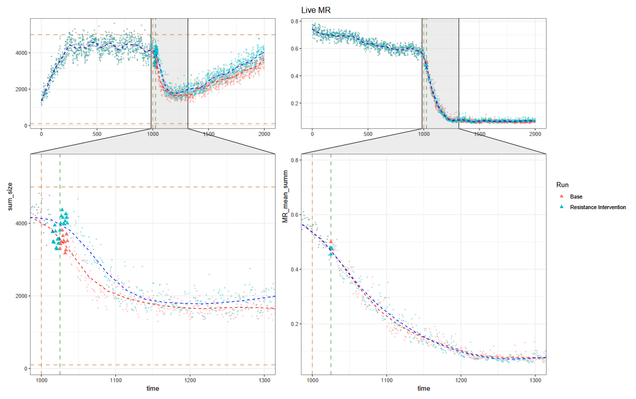

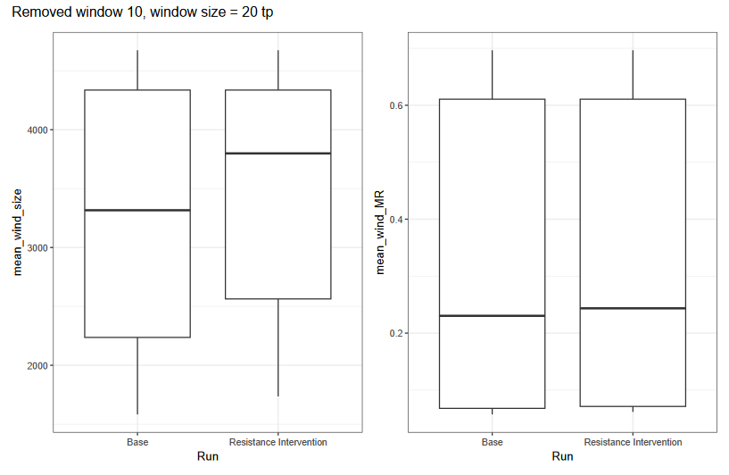

## Intervention_1000-0.15-0.1_T1025:

* Recruitment adjustment = 0 & ^2
* MR=0.12
* MR introduced at 1000
* intercept_timepoint = 1025
  + Dropped mean MR from 0.499 -> 0.4305
* intercept_indiv = 1000
  + Hit peak (*N =* 5067)
* intercept_MR_mean = 0.15
* intercept_MR_sd = 0.1

## Intervention_1000-0-0_T1025:

* Recruitment adjustment = 0 & ^2
* MR=0.12
* MR introduced at 1000
* intercept_timepoint = 1025
* intercept_indiv = 1000
* intercept_MR_mean = 0.0
* intercept_MR_sd = 0.0

Result:

Minimum population drop post-MR introduction:

> live_size_wind_mean %>%

+ group_by(Run) %>%

+ summarise(min_pop_size = min(mean_wind_size))

# A tibble: 2 × 2

Run min_pop_size

*<chr>* *<dbl>*

1 Base 1583.

2 Resistance Intervention 1904.

